Peer-graded Assignment: Connecting to Multiple Data Sources

The goal of this assignment is to demonstrate you are able to connect to various data sources and import into Tableau. You will create a final worksheet that includes screenshots of your work to show you were able to connect and import the data. A successful assignment will illustrate your ability to connect, merge, and import data to set yourself up to begin analyzing your data.

**Step-By-Step Assignment Instructionsless**

**Setup instructions:**

Before you begin this assignment, please download and save a copy of the Orders and Returns Superstore Sales data workbook, found here:

[Orders and Returns Sample Superstore Data Workbook.xlsx](https://d18ky98rnyall9.cloudfront.net/_da01b5ca8d327d8730df6a7f868914ab_Orders-and-Returns-Sample-Superstore-Data-Workbook.xlsx?Expires=1582675200&Signature=jRdOOr-6gpW6AryjEHul6jiXAIXBfEp0GEr1ldg6NXv0e4EvpbraP6QNCxeSK1CEZg5jwokFC6QXYFPwBoRMmvovxXEnoSkOx-bss~H1tEJweMpx7dHP6LsTAIO-zYMdQl5oPvj8t2nCXTeGHq7-vnehystEFWybndutTigCPcM_&Key-Pair-Id=APKAJLTNE6QMUY6HBC5A)

You will also need to create a Tableau Public profile to save your work. To do this, please follow the prompts at :[https://public.tableau.com/s/](https://onlinehelp.tableau.com/current/pro/desktop/en-us/publish_workbooks_tableaupublic.htm)

**How to create your assignment:**

Follow the instructions below to prepare your assignment:

**Part 1**: Using the Orders and Returns Superstore Sales.xls data workbook, connect to the Orders data, and complete the data import process to begin analyzing your data. Then save the output to your Tableau Public profile as its own visualization and copy and paste the URL to a Word document.

**Part 2:**Using the Orders and Returns Superstore Sales.xls data workbook, connect to the Orders and Returns data sources, and complete the data import process to begin analyzing your data. Then save the output to your Tableau Public profile as its own visualization and copy and paste the URL to a Word document.

**Part 3:** Using the Orders and Returns Superstore Sales.xls data workbook, connect to and merge the Orders and Returns data sources using a common variable, and complete the data import process to begin analyzing your data. Then save the output to your Tableau Public profile as its own visualization and copy and paste the URL to a Word document.

Your final assignment should be a Word document or PDF version with three separate links to each of the three parts listed on your Tableau Public Profile.

**Grading Criteria Overviewless**

You will be required to submit three (Part 1, Part 2, Part 3) Tableau Public profile URLs to demonstrate you were able to successfully connect and merge data from the given dataset.

Part 1:

Link to Tableau public:

https://public.tableau.com/profile/bhuvanesh3834#!/vizhome/Tableau-FV_W3_P1/Sheet1?publish=yes

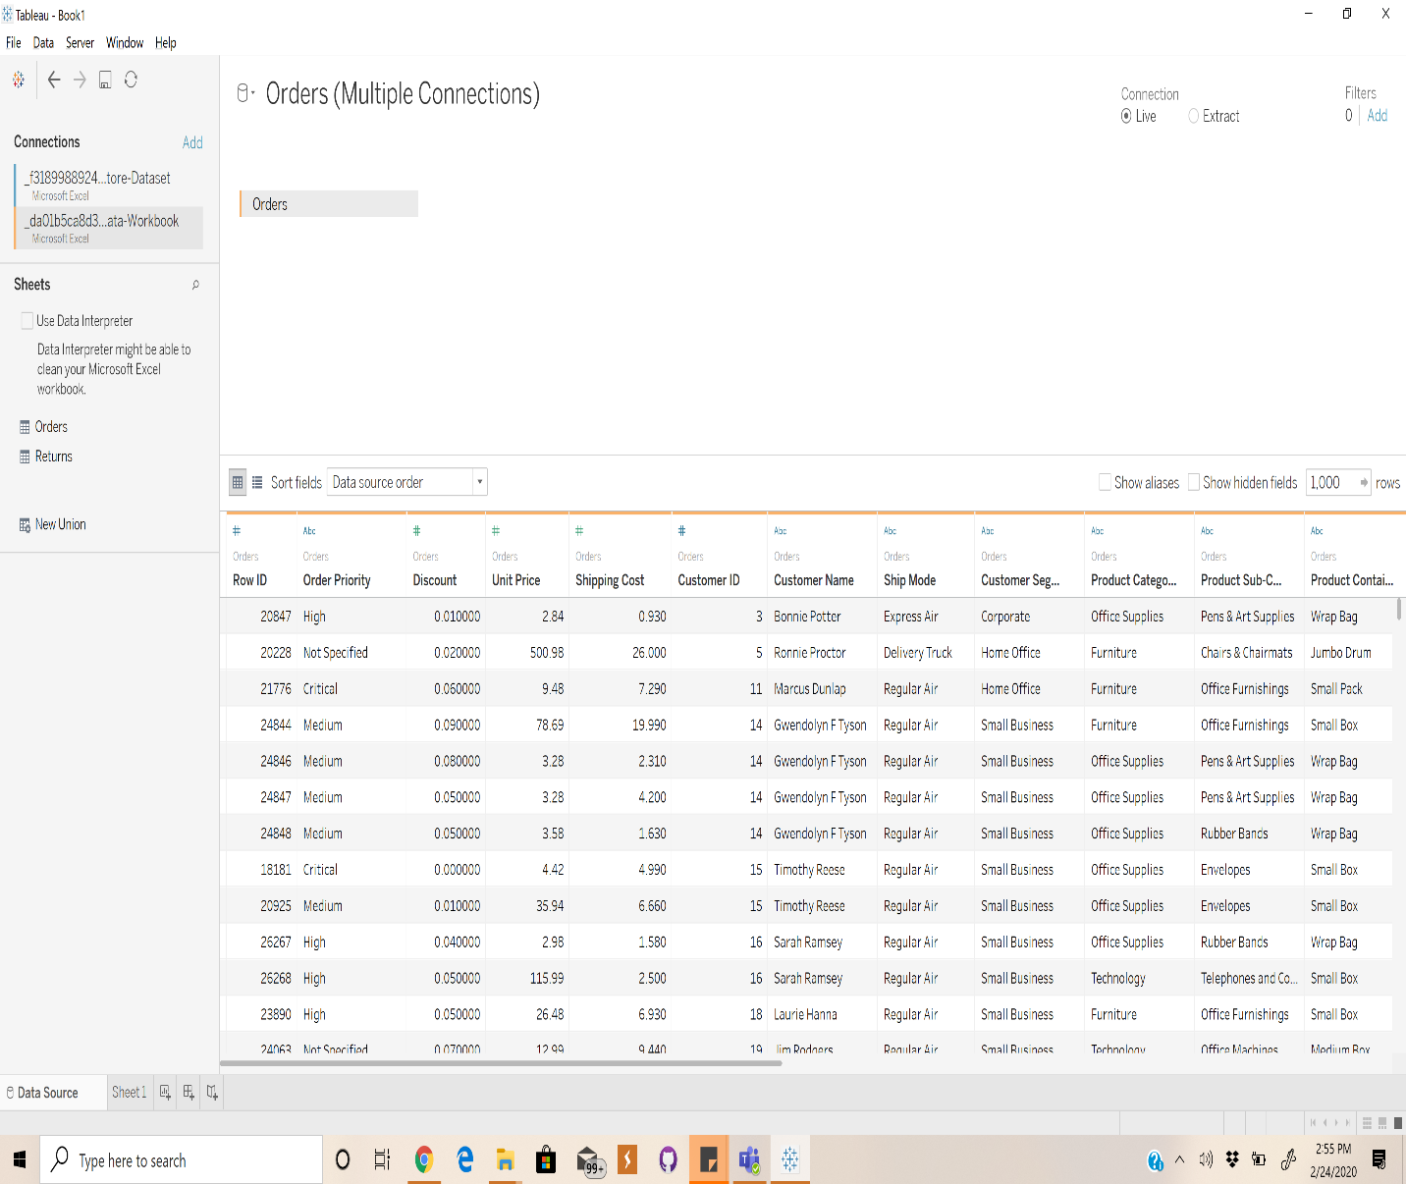

* Connecting to Order data and Importing Order dataset. Then it is analyzed in workspace.

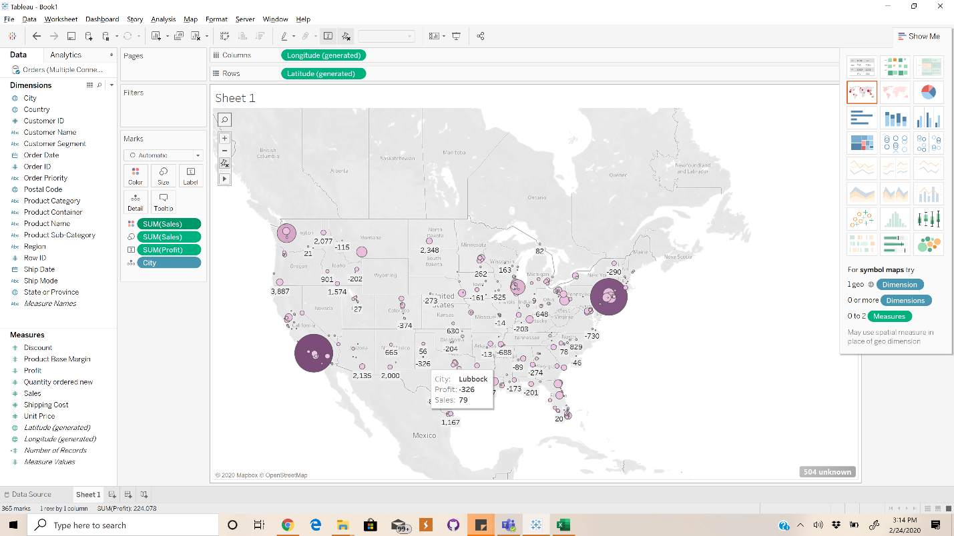

* This analysis is Performed to visualize the cities which has highest sum of sales.
* From the chart we can infer that Cities like Los Angeles, New York city, Washington etc. are among the top cities in rankings of sales metrics.
* Used Symbol Maps Layout for geographical representation of the sales data. Text label is used to represent the data metrics.

Part 2:

Link to Tableau public:

<https://public.tableau.com/profile/bhuvanesh3834#!/vizhome/Tableau-FV_W3_P2/Sheet2?publish=yes>

* Orders and Returns data are connected.
* Relationship is established using Relationship Connector from Files.
* We establish connection between dataset which had order ID as common feature.

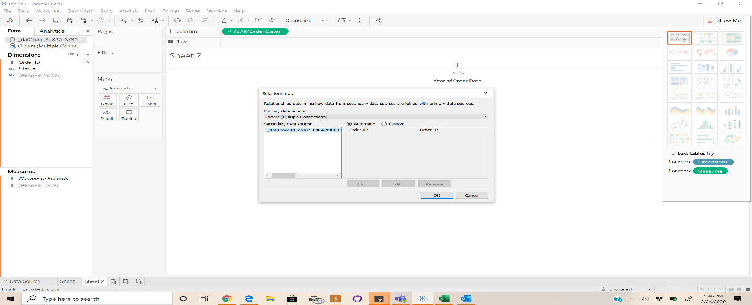

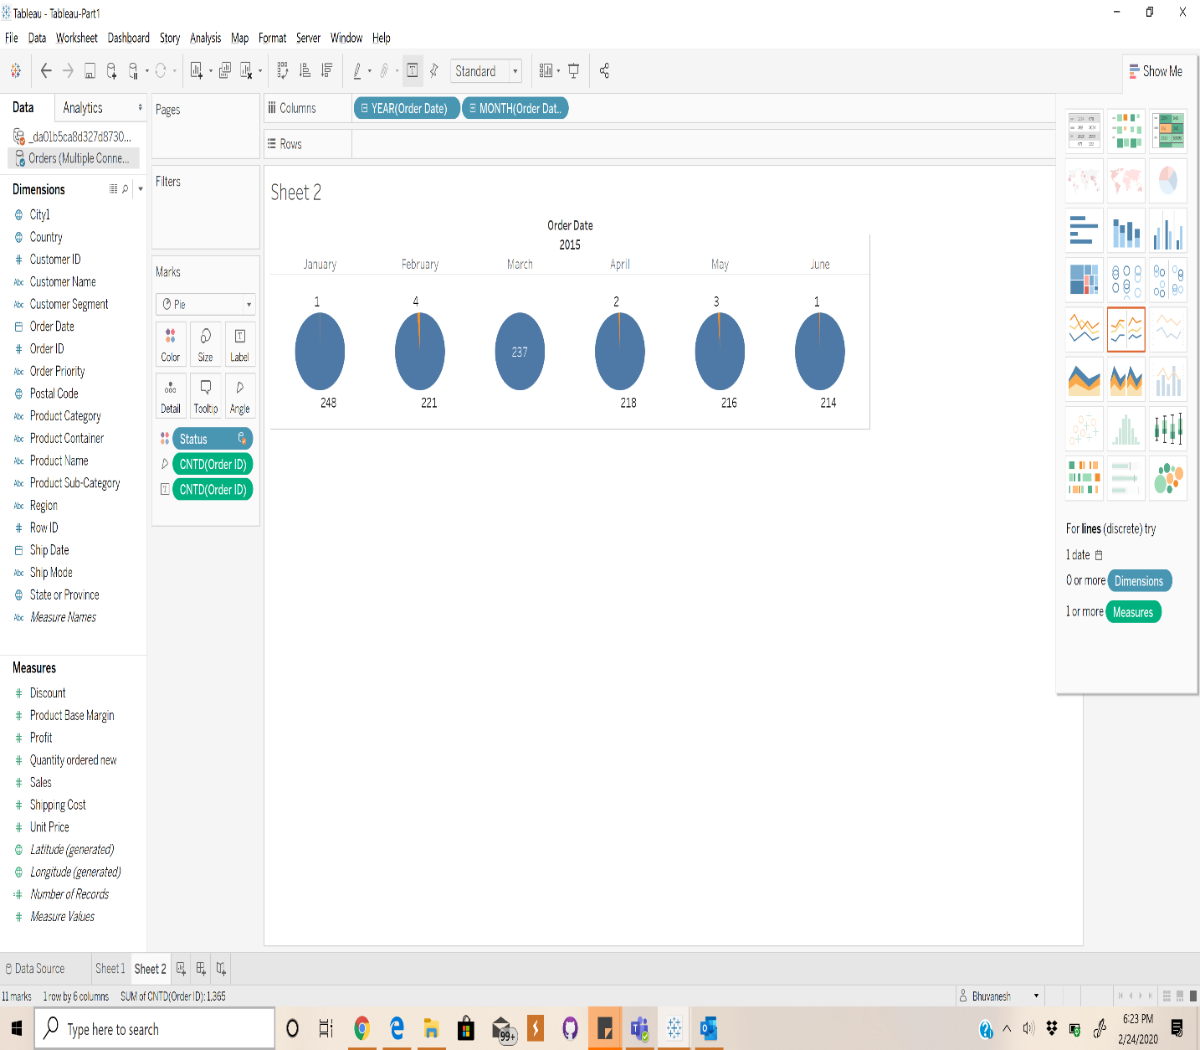

* Pie chart Layout is used for visualization of Orders Date and Status.
* We take Individual Months of the year and represent the status of each month respectively.
* Distinct count of Order Id Is obtained.
* Status is colored in two different forms orange and blue resp.

Part 3:

Link to Tableau public:

<https://public.tableau.com/profile/bhuvanesh3834#!/vizhome/Tableau-FV_W3_P3/Sheet4?publish=yes>

* Orders and Returns data are connected.
* There are many possible joins which can be used to connect the two datasets either inner join, outer join, right join or left join.
* When we inner join we tend to get only less data, so we join them using Right join.

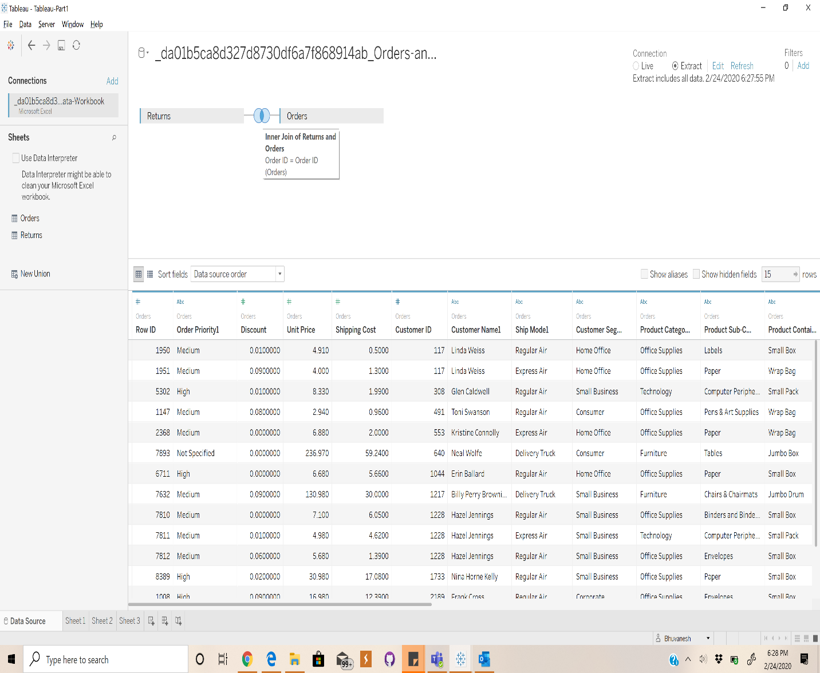

* Pie chart Layout is used for visualization of Orders Date and Status.
* We take Individual Months of the year and represent the status of each month respectively.
* Distinct count of Order Id Is obtained.
* Status is colored in two different forms orange and blue resp.

